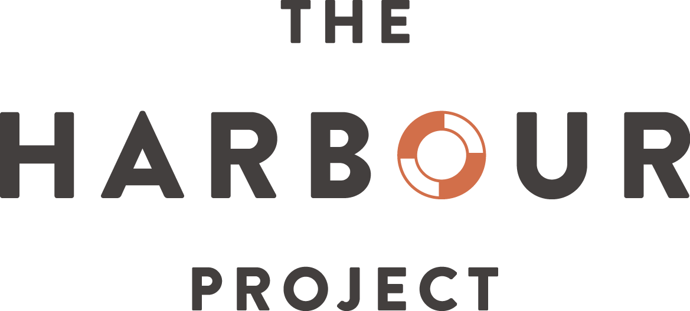

We aid refugees and asylum seekers across Swindon.
We give friendship, advice, practical help and hope.
We are The Harbour Project.

Our History
Updated Feb 2019

Contact details
The Harbour Project
St Luke’s Hall
Broad Street
Swindon, SN1 2DS
http://harbourproject.org.uk/
Tel: 01793 611 682
For almost twenty years, The Harbour Project has grown and evolved as it has helped hundreds of asylum seekers and refugees (our Visitors) who have passed through Swindon. Its focus on friendship and practical help, however, remains unchanged.
i) Origin and first decade
The Harbour Project was born in May 2000, when Kosovar Albanian refugees fled the fighting in former Yugoslavia. It was founded with funds from the Baptist Church and help from other churches and groups.
The charity was the brainchild of Dorothy Leith, as Andrea Hughes, a founder member recalls: “(Dorothy) had this idea for a charity, after we were all moved and distressed by the war in the Balkans. There was a mass exodus of refugees and we felt that we ought to do something.”
Other early members included: Vernon Griffiths, Rev Guy Donegan-Cross, Elaine Long, Faith Mitchell, Elspeth Woollen, and Stephanie Glennie. ‘“Provide a safe space” (were) the words which inspired us at the very beginning of planning the Harbour’ recalls Stephanie.
The focus was to provide friendship, free refreshments and emergency help with food and clothing; and to give basic advice and signpost people to appropriate agencies. A lady who arrived from Kosovo in 2000, together with her husband and two children, later became a Harbour Volunteer. Now in her fifties, she recalls “Harbour gave us amazing support, especially with the paperwork. What I got I wanted to give back”
In 2003, The Harbour Project for Swindon Refugees and Asylum Seekers was registered as a Charitable Trust: Reg. Charity No. 1097227. Its annual income in 2004/5 was around £30,000. It employed a member of staff and with The Evaluation Trust identified current impact and areas for development. Inevitably, with limited funding and prioritisation of Visitors’ welfare, organisational development was gradual. A 2-year Capacity Building award from the Big Lottery in 2005/06 supported an office in John Street, and an Administrator; and in 2006, a pilot scheme to employ a Drop-In Coordinator was effective and popular with Visitors. Fluctuating income, however, meant both posts were lost temporarily. In 2006, the Home Office designated Swindon a ‘dispersal town’ for asylum seekers; and a 3-year grant (instead of annual awards) from Swindon Borough Council from 2006/7 offered welcome stability, and recognition of this status. A web site was launched, and laptops were provided for study. Annual income in this period was around £70,000. Annual fundraising events were put in place and by 2007/08 a Lunch Club was established, together with activities for families and young children.
In 2008/09 a new Administrator was appointed and additional office space was made available in the same building as the Drop-In; then in 2009 a new Drop-In Coordinator post was established and filled. Together these changes significantly increased efficiency and enabled growth.

ii) Consolidation
By 2009/10 a new contractual arrangement with Swindon Borough Council enabled some short term (2-3 years) planning, and The Project steadily expanded its services. The Drop-In was open for an average of 21 sessions per calendar month. Trustee Ira Muir took on a role as Events Coordinator, beginning an expansion of leisure and recreational activities for Visitors. Office equipment and internet access were upgraded. The next year, sewing and jewellery making classes began.
A step-change in development came with an award of £197,000 from the Big Lottery Fund for the period 2012/2017. Nan Bains was recruited as Project Manager. The award not only enabled rapid expansion and a wider range of activities but also provided medium-term resilience around which other initiatives could coalesce. More classes were offered, most significantly in English (providing access for asylum seekers who would otherwise be unable to obtain such education) and in computing, cooking and keep-fit. Social events increased to include annual ‘away trips’, local visits, and seasonal celebrations. A Harbour football team was established and continues to this day. Five-days-a -week opening was fully established.
A ‘virtuous circle’ was created: stability enabled growth, which engendered confidence leading to more outreach, which in turn attracted more supporters and more funding. It became possible to fill vacancies with people already committed to The Project. In 2012/13 former Volunteer Giles Matthews became Drop-In Coordinator, introducing new procedures around Home Office liaison, accommodation, access to healthcare etc. and improving data collection and recording. In 2013/14 Annie Vickers, also a former Volunteer, became Project Administrator as the support base widened and budgetary control became more sophisticated.
Visitor numbers rose from an average of 25 per session in 2009/10 to 35 by 2013/2014, supported by Volunteers from a cohort of around 25-30.

Although it could not have been foreseen, these parallel changes of increased services for Visitors, especially around social integration, and increased operational efficiency and community outreach, were to be crucial in enabling The Project to meet unprecedented challenges in the years ahead.
iii) Growth, new challenges and development
By 2013/14 annual income topped £100,000 for the first time. The welcome visit by HRH The Princess Royal in 2013 symbolised growing recognition of The Project in the town. Despite a national squeeze on local authority budgets, Swindon Borough Council committed 3-year funding from 2014/15, albeit at a reduced rate.
In 2015/16, there was an unprecedented rise in the number of asylum seekers dispersed to Swindon. (An ongoing issue for The Project is that it cannot accurately predict future needs.) Around the same time, and affecting refugees, there were significant changes to the Benefits System. This period could have become a ‘perfect storm’, but The Project had robust procedures and sufficient flexibility to meet the challenges without losing its important ‘family’ atmosphere of support and practical help. In May 2015, Mindy Sandhu was appointed to a new post as Assistant to the Drop-In Coordinator, thus strengthening The Project’s ‘first responder’ capacity. The winter of 2016/17 saw another major challenge when a significant number of asylum seekers were given Leave To Remain almost simultaneously at a time close to the Christmas/New Year Season when public and other services can become overstretched. Again, The Project’s procedures proved resilient.

Growth continued throughout these challenging years, with more English classes, a Women’s Group, a monthly Free Shop, and an evening ‘Language Lounge’ in partnership with New College that linked sports and games with learning English. Another innovation was provision and maintenance of bicycles for Visitors, giving much need independence, especially for those placed in accommodation on the outskirts of the town.
This growth was possible because of increased support and funding from Trusts, corporate and individual donors, and The Project’s own fundraising activities. Volunteer numbers rose steadily to around 60 by 2016/17, with several specialising in areas such as English classes, art workshops, and bicycle repair.
Organisational developments included a more cost-efficient telephone system, laptop upgrading and use of additional space for daily English classes, which underpinned the core befriending and practical settlement work of the Drop-In. Establishment of a Receptionist post in 2016 improved prioritisation and workflow in the Drop-In, enabling Staff and Volunteers to focus on those with the most pressing issues.
More training was provided for Staff, Volunteers and Trustees; and processes put in place to assess Visitors’ thoughts about Harbour’s performance, with Focus Groups (from 2015) and formal Evaluations (from 2016).
iv) New constitution and restructuring
By 2016/17 annual income had risen to over £155,000. The Project changed its legal status to that of a Charitable Incorporated Organisation, Reg. Charity No. 1171368. New procedures were developed in risk management, policy development and communications, informed by findings from an external independent review of Harbour’s structures and governance, funded by Big Lottery.
In June 2018, a CEO was appointed for the first time. The part-time post, which reports to the Chair of Trustees, was filled by former Volunteer and Trustee Claire Garrett, after a national recruitment campaign. Additional restructuring took place, reflecting Staff development and increased financial monitoring, including a new part-time book-keeper post. This reflected Harbour’s commitment to diversify its funding base and to develop skills for managing an unpredictable and changing demographic of Visitors, changes in UK Benefits, and legal requirements in areas such as data protection and safeguarding. For the first time, several staff obtained qualifications from OISC (Office of the Immigration Services Commissioner).
In 2017, the Big Lottery Award was renewed with funding up to 2022, for work including: one-to-one support of Visitors’ psychological wellbeing, preparing refugees to seek and find employment and so reduce reliance on Benefits; and ways to reduce social isolation among women asylum seekers and refugees. New initiatives included: ‘Steps2Work’, an advice and mentoring programme drawing upon new links with Swindon’s business community; identifying potential needs in order to shape one-to-one help with psychological issues; an afterschool Homework Club for 4-14 year-olds and family; hosting a Work Experience student, and engaging with students on the National Citizenship Scheme.
The needs of Visitors remain at the heart of everything the Harbour does. Care is taken to ensure that organisational and operational evolution never impairs the essence of the Harbour’s welcome and support, which is based on friendship and mutual respect.

“I can scarcely believe how the Harbour, which began with such a small group of people, has blossomed far beyond any expectations we might have had..” Pam Summerhayes.
“What a joy to look at the website, watch the video, and see how far the vision has come - amazing!” Guy Donegan Cross

v) Enhanced civic engagement
The Harbour has continued to attract generous support from groups and individuals across Swindon and beyond. It has strengthened synergistic collaborations with civics groups and charities. Examples include: working alongside Swindon City of Sanctuary SCoS), Amnesty and Voluntary Action Swindon during Refugee Week 2017, ‘Different pasts, shared future’. In 2018, a Harbour Project Trustee was appointed a Trustee of SCoS; and some Volunteer training was held jointly with Citizen’s Advice and SCoS. Weekly gatherings at Darkroom Espresso are an example of a Harbour and SCoS working together to provide support for Visitors. The Harbour also refers individuals to the SCoS ‘Room for All’ hosting scheme.
Harbour’s profile has steadily increased, through public events, social media and representation and one-to-one meetings both locally and nationally. In December 2017 Harbour participated in a meeting of the All Party Parliamentary Group for Social Integration at Westminster in December, to mark publication of results from British Academy commissioned research into social integration. The Harbour has also begun to receive requests for partnerships and links with individuals and groups nationally. Naturally, however, engagement is focused around Swindon where already good working relationships have been strengthened with local MPs, the MEP, The High Sherriff of Wiltshire, The Councillors, Chief Executive and Commissioners of Swindon Borough Council, and other community leaders. The Harbour also continues to benefit from generous support from many companies (large and small) in the town and from business groups. Lord Joffe became Harbour’s first patron and was succeeded by Lord Wills (former Swindon North MP).
A ’Pride of Swindon’ Award winner in 2017, The Harbour was chosen as one of three Mayoral sponsored charities in 2018 by incoming mayor of Swindon Cllr Junab Ali. In 2018, Visitor and Volunteer Faisal Nawaf won the Pride of Wiltshire ‘Volunteer of the Year’ Award, and Harbour’s Chair of Trustees David Rowlands won the Lifetime Achievement Award.
In some ways the The Harbour’s history mirrors that of the metaphorical journey taken by asylum seekers. Initially, everything focused on the Drop-In providing an initial welcome and immediate support on essentials such as help with complying with Home Office rules, emergency provision of basic food and clothing if needed and help with access to healthcare, or with accommodation or transport problems. This remains our core activity.
Once established and as funding became more secure, The Harbour could offer additional services, just as new Visitors make new friends, learn new skills, (especially in English) and acquire the confidence to integrate into the local community.
The Harbour has typically welcomed Visitors from 40 or more countries at any time. Relative numbers from different countries have reflected the chronology of global conflict and oppression: Visitors from Kosovo/Albania, being followed by more fleeing Somalia, Sudan, Eritrea, Pakistan, Afghanistan, Iran, Iraq and Syria. Iran has recently become the country from which we have the largest number of Visitors.
Throughout, The Harbour Project has relied on goodwill and support from many organisations and individuals in Swindon and beyond. Details of supporters, funders and the Annual Accounts and Annual Reports are available.
The Project remains an independent, non-political and non-religious organisation.

